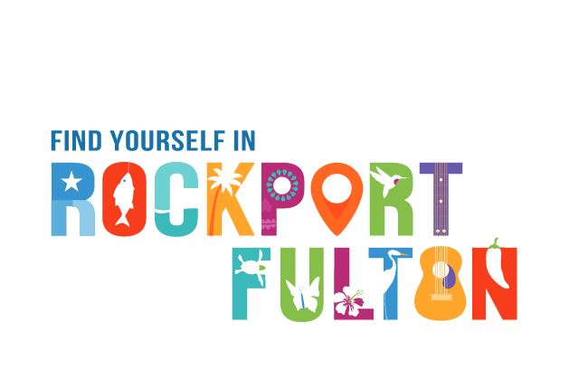

For Immediate Release
Contact: Sandy Jumper
Director of Tourism and Events
Rockport-Fulton Chamber of Commerce
tourism@1rockport.org
(361) 729.6445

George Strait Lends His Voice for Rockport-Fulton Comeback Campaign
to Boost Tourism After Destruction of Hurricane Harvey

(ROCKPORT-FULTON, TX) — Country superstar George Strait is lending his voice pro bono for several TV and radio spots as part of a Comeback campaign, “Find Yourself in Rockport-Fulton,” to help revitalize tourism in the wake of Hurricane Harvey which wreaked destruction on the Rockport and Fulton communities on Aug. 25, 2017.

The two TV commercials will begin airing in June in San Antonio and Austin, while the three radio spots will air in the Hill Country and New Braunfels. They were a collaborative effort created for the Rockport-Fulton Chamber of Commerce by San Antonio-based Helen Thompson Media, The Pulse Group of Austin and Andrew LaVanway of ICF of Fairfax, Va. In addition, Strait’s “Back to Being Me” is played in the background of the TV commercials as he provides the voiceover.

“Hello everybody. This is George Strait, and I’ve traveled all over yet there’s no place I’d rather be than right here in Texas,” he says in the TV and radio spots. “One of my favorite places is the Rockport-Fulton area on the coast. Every time I cross over the Copano Bridge to see that beautiful bay, it feels like home. I hope you find yourself in Rockport, Texas soon.”

Betty Hattman, chairman of the Board of the Rockport-Fulton Chamber of Commerce, said the Come Back Campaign is a major step in the recovery process of the Gulf Coast communities.

“Tourism fuels the economy of Rockport-Fulton. Prior to the storm, direct spending numbers from tourism were reaching $101.1 million annually,” Hattman said. “Tourism for Aransas County employs more than 1,300 people contributes $1.4 million to local government and $5 million to state government coffers. We are going to lose what businesses we have if we don't get the economy back flowing.”

Paula Dean, chairman of the Tourism Development Council of the Rockport-Fulton Chamber of Commerce added that “the creative aspect of the campaign reveals the feeling in all of us as we describe the mystical, spiritual affection we have for the Rockport-Fulton area.”

For more information about the Come Back campaign and other tourism information, visit Rockport-Fulton.org or call 1-800-242-0071 or 361-729-6445.

