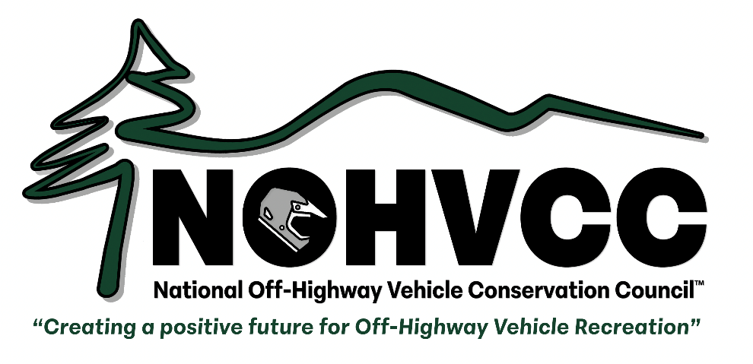

2025 NOHVCC Annual Conference

**SCHOLARSHIP APPLICATION**

**Applications due by June 1, 2025**

The National Off-Highway Vehicle Conservation Council will award scholarships for a limited number of qualified individuals to attend the NOHVCC and/or International Off-Highway Vehicle Administrators Association Annual Conferences in Bend, Oregon on October 10-11.  We recognize that attending the Conferences is an expensive proposition, so we want to make sure we have the best and brightest from the OHV community participate.  These scholarships will cover the cost of travel, lodging, registration and most meals of awardees.

**Invited to apply are State Partners who will not receive a travel grant, agency personnel (particularly those who cannot receive reimbursement for out-of-state travel) and others interested in attending.**

Conference activities and lodging will be hosted by:

RiverHouse Lodge

3075 N Business 97

Bend, OR 97703

We have an exciting conference planned with a focus on the local successes of the Oregon State OHV Program and their partners. We will also present on issues and successes facing the OHV community across the nation. If you wish to attend, please fill out and return your scholarship application as soon as possible.

**To apply for a scholarship, please provide the information requested on the following page by June 1, 2025.**

**Send completed applications to** [**trailhead@nohvcc.org.**](mailto:trailhead@nohvcc.org)

2025 NOHVCC Annual Conference

**SCHOLARSHIP APPLICATION**

**Applications due by June 1, 2025**

Name:

Address:

Phone: E-mail:

Name of organization(s) you represent, if any:

Your position or title within the organization(s), if any:

Type of organization(s), if any:  Government Agency  OHV Club or Association  OHV Industry  NOHVCC Associate State Partner  Other, please describe:

Please briefly describe your involvement in OHV recreation (as an enthusiast, advocate, vocation, etc.):

Please briefly describe what you would hope to learn at the NOHVCC and/or INOHVAA Annual Conference:

Based on your expectations, please briefly describe how you anticipate you would apply any knowledge or tools acquired at the conference:

Please be advised that NOHVCC may contact any organizations listed above, and may publicize the names of award winners

Sign here: Date:

**Send completed applications to** [**trailhead@nohvcc.org**](mailto:trailhead@nohvcc.org)**, or by mail to: NOHVCC, P.O. Box 399, Vaughn, MT 59487.**